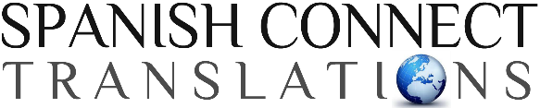

367 Talon Dr., Rexburg, Idaho, 83440 beverly@spctranslations.com
spctranslations.com
602-684-4009

DOCUMENT OF CERTIFICATION

I, Beverly Zayas Hayes, a translator of proven expertise and an active member of the American Translators Association by a certificate attesting thereto issued on March 2016, do hereby CERTIFY that I translated the attached document from Spanish into English and that, to the best of my ability, it is a true and correct translation. I further certify that I am competent in both Spanish and English to render and certify such translation.

In Rexburg, Idaho, USA, on the ____________ day of _______________, ______.

_____________________________________________
Beverly Zayas Hayes
Spanish Connect Translations
ATA Associate Member # 264818
STATE OF IDAHO
COUNTY OF MADISON

I, the undersigned Notary Public, do hereby certify that Beverly Zayas Hayes appeared before me and acknowledged that she is an active member of the American Translators Association and that she translated this document for __________________________________ of her own free act and deed.

In witness whereof, I have set my hand and seal, this ___________ day of
______________________________.

_____________________________________________
NOTARY PUBLIC

